User Guide for the Multi- Agent-System

Steps:

1. Upload all the relevant documents, I had created a folder called Data in which I had uploaded the error codes pdf, and in the central folder I had uploaded telecom CSV.

1. Once you upload the document , then let me go step by step, first install the all the requirements as mentioned in the code

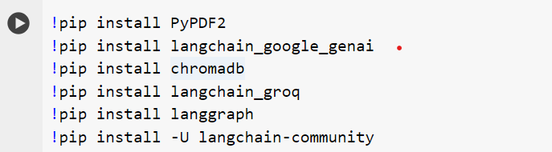

1. Then we created a SQL local db, in which we loaded the CSV file, if you have different path for CSV file , then you can change it accordingly.

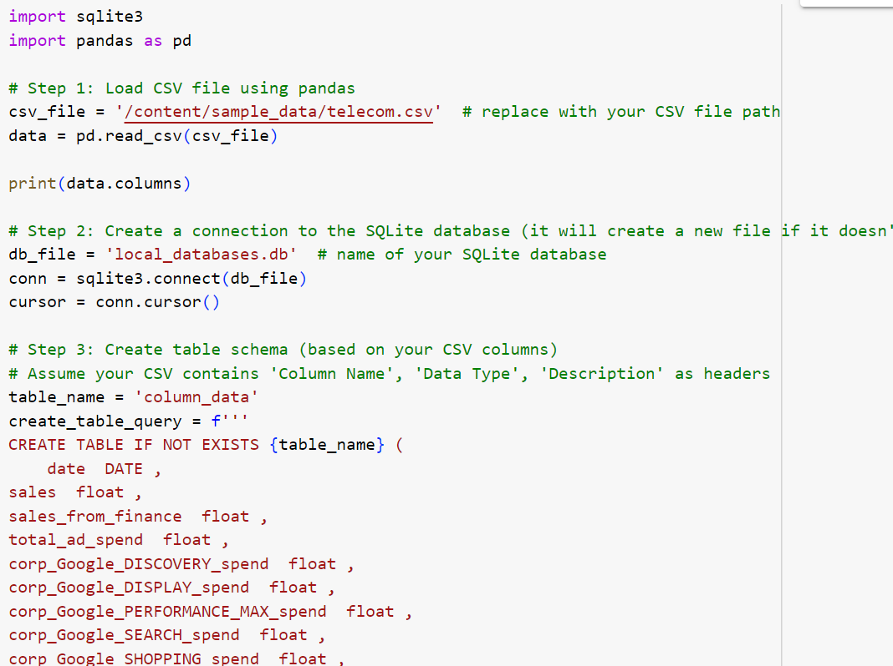

You can see the local db getting created.

1. In this step i have created a prompt template in which I had feed the entire schema with the description and column names, and in that template. You need to replace the gemini-api-key with your gemini api key.

As I wanted to populate source for both the agents, for the marketing data agent, we have only one source which I have mentioned as below, you can update it to the path where you have your CSV file.

1. Now in the next step we have build the embedding system, where we read files from the “Data” folder for Technical support agent. You need to replace the gemini-api-key with your gemini api key.

This where you can mention the folder, incase you follow a different structure.

1. Then we have built the retrieval system, in which we take the user query as input and generate the response and source, we have defined the functions for the same. You need to replace the gemini-api-key with your gemini api key.

1. Then in the next step we have built the agent orchestration system, where have defined the intent-recognition framework, added the nodes and provided conditional edge according to the needs. You need to replace the groq-api-key with your groq api key.

1. In the next step we can validate with questions, on how our multi-agent-system is working. We can send a question in the input question and execute it to get the result. In result we will get what agent is invoked, what is the answer, and from where we are getting the result.

